Publishing and Syncing Webpages in Sitefinity SOP

25 May 2016

Purpose—To publish and sync webpages and objects in Sitefinity

1. Publish the items in Sitefinity
   * In a browser, navigate to <http://ldiweb2012dev/Sitefinity/dashboard> and log in

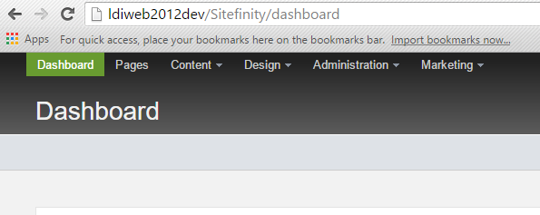

* + Scroll to the bottom section labeled “Everyone’s content”

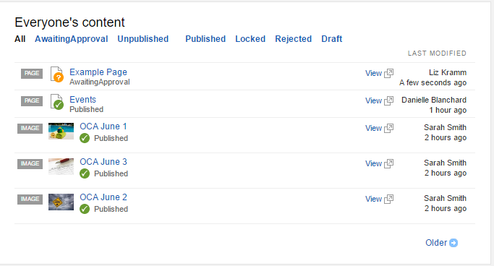

* + Click on the title of the item to be published
  + Publish it by clicking “Publish” at the top of the page

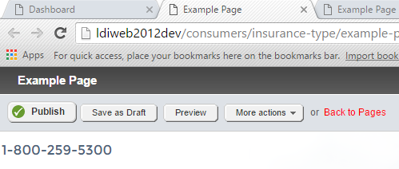

1. Sync the items in Sitefinity
   * Under the “Administration” tab, select the “Staging and Syncing” option\*

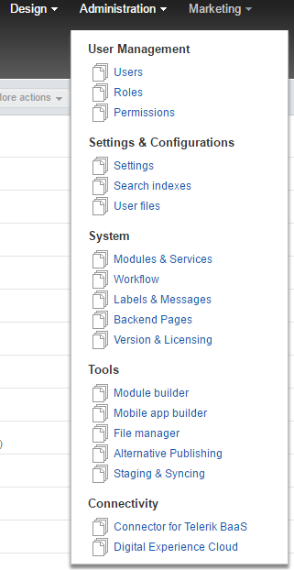

\*NOTE: the options under this menu vary widely depending on the permissions the user has in Sitefinity.

* + In “Pages waiting for sync” select radio button “Selected items only” and select the check box next to the page you wish to sync

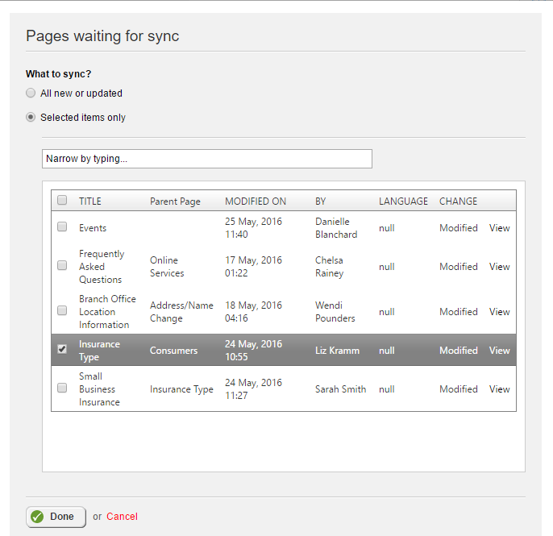

* + Click “Sync now” to sync the files now, otherwise, click “Schedule syncing” to sync them at a later date

